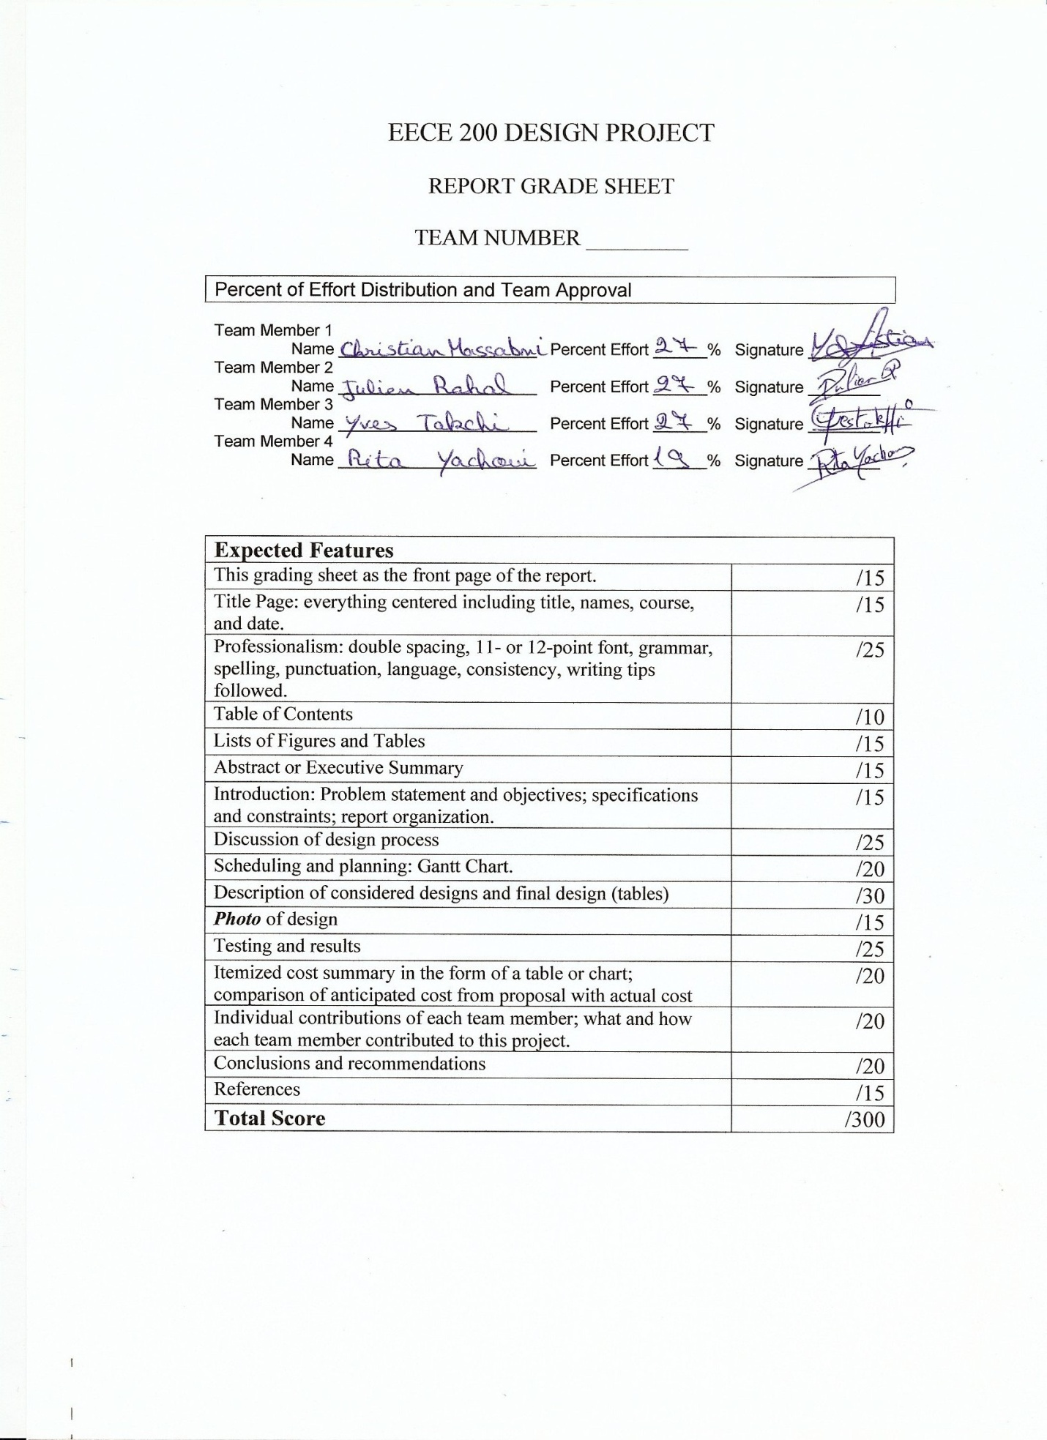

Department of Electrical and Computer Engineering
EECE 200 – Introduction to Electrical and Computer Engineering

Design Project Fall 2011-2012
Three-Floor Elevator
- Final Report –

Thursday, January 26th, 2012

Team -11-

Christian Massabni
Julien Rahal
Rita Yachoui
Yves Takchi

- Introduction
- Problem Statement
- Specifications
- Restrictions
- Objectives
- Report Organization

- Work Description
- Design Process Discussion
- Gantt Chart
- Alternative Designs Discussion

- Testing conditions and Final Results

- Cost Summary

- Team Members’ Contribution

- Conclusions

- References

- Appendices

-i-

Fig 1. Hardware overview
Fig 2. Cabin
Fig3. Pulley and small wheels
Fig.4 Lifting System
Fig 5. Door and closing mechanism
Fig6. Door sensor system
Fig 7. Dc fan
Fig. 8 iphone connected to speedy
Fig. 9 Interface Board
Fig. 10 Gantt Chart
Fig. 11 Positioning System
Fig. 12 Door Sensor
Fig. 13 Door System
Fig. 14 Lifting System

-ii-

Anticipated Cost Summary

Final Cost Summary

-iii-

Our aim is to create a functional elevator. Our elevator should go up and down three floors. It responds to calls made on the different floors and will serve them according to the order in which they are placed. The cabin’s position is permanently indicated on a 7-segment display. Once the cabin reaches the desired floor, the door opens for 7 seconds. If no obstruction is detected by the photovoltaic sensor, the door closes automatically after the 7 seconds. Otherwise, it remains open until the obstruction is cleared. A thermo-sensor is installed inside the cabin. When this sensor detects an elevation of the ambient temperature, it puts the elevator on emergency mode. This consists of turning on a dc fan and some red LEDs while turning the white ones off.

-iv-

- Problem Statement

The project consisted of programming a 3-floor model elevator, using National Instruments Labview software, and designing as well its hardware. The program is downloaded to a NI Speedy-33 DSP board that runs on standalone mode.
This project contributes to a big part of our final grades in EECE 200. Therefore, for us to pass this course, it is necessary to complete this project.

- Specifications

- Digital Inputs
    - Three bump sensors fixed on each floor to indicate the cabin’s position.
    - Three push buttons on each of the floors to allow the user to call the elevator.
    - A photo resistor inside the cabin near the door entrance that is constantly hit by a laser light.
    - A temperature sensor installed in the cabin.
- Analog input
- The built in microphones on the speedy 33 board. Three specific tones are assigned to each level which will allow the program to determine what itinerary to take.

- Digital Outputs :
- Two digital outputs to a seven segment display used to display the position of the elevator.
- Three digital outputs that control the motors that opens the doors of each floors.
- One digital output controlling the lifting motor.
- One digital output controlling the lifting motor's direction.
- One digital output that controls a dc fan installed in the elevator.

- Restrictions
Since were recently introduced to LabVIEW, we were obliged to do personal researches in order to overcome some difficulties and weaknesses. Also, the model had to be accomplished and delivered on time. Moreover, we had to work in a group and try to cope with all the restrictions we had and limit ourselves to the resources available to us. In fact, we had to do everything on our own, and hence were constrained to our abilities.

- Objectives
This project was assigned to us for different reasons. Its main purpose was to enhance our LabVIEW programming skills and apply them on a practical application. It’s also intended to teach us how to figure out solutions to the problems we face. This helped us understanding the problem solving process. Furthermore, one of the project’s targets is to develop our ability to work and cooperate in a team of engineers. Finally, the project’s goal was to familiarize with the design and development of engineering projects.

- Report Organization
In this final report concerning our project, we’re going to discuss the whole design process we went through. We will also represent our time planning in a Gantt chart. Then, we will about the project.discuss each design alternative, while focusing on the final one. Later, we will analyze the testing results of the design. In addition, the final cost summary will be compared to the one anticipated in our proposal. At the end, we will state each member’s contribution to the completion of this project and the part where he was the most effective. We will then be able to conclude

- Design Process Discussion
The hardware skeleton is mainly composed of wood components assembled together by aluminum strips which give rigidity and stability to the whole structure. (Fig.1)
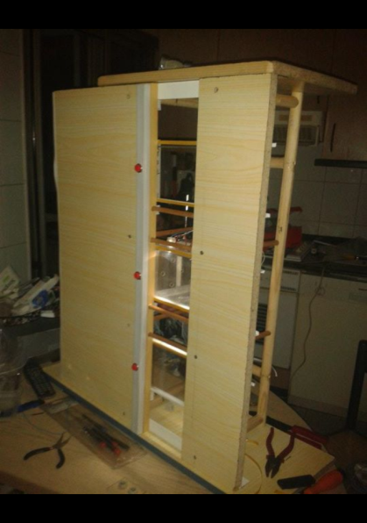

Fig. 1 Hardware Overview

The cabin, however, is made of 5 thin plexi-glass plates, sealed together to form a cube opened from only one side (Fig .2). The material is chosen in a way so that the cabin doesn’t weight much. This makes the lifting easier and reduces the pressure on the motor.
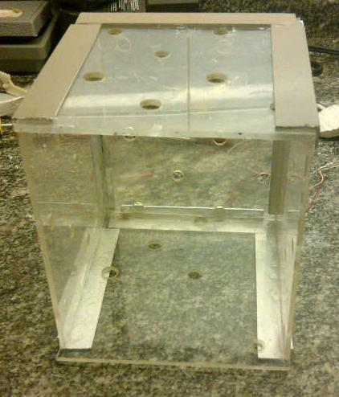
Fig. 2 Cabin
The pulling motor is placed on the top of the shaft (Fig. 4). A pulley is fixed at the rotating end of the motor. In addition, two small wheels are fixed near the pulley on opposite sides (Fig. 3). A cable is attached from one end to the top of the cabin. The other end holding a counter-weight. The two small wheels were installed in order to reduce and even eliminate the friction between the cable and the wood.

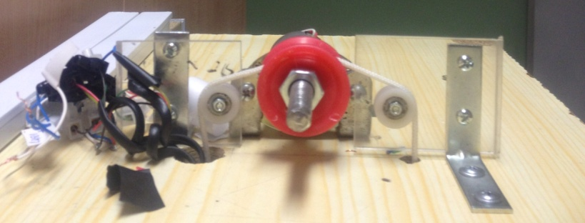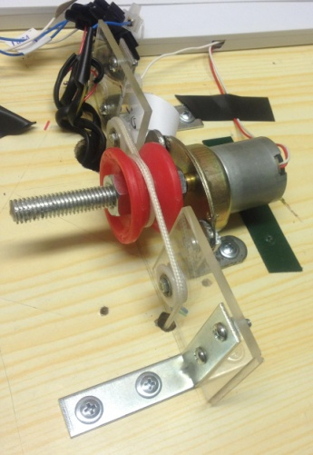
Fig.3 Pulley and small wheels Fig. 4 Lifting system

3 CD-ROMs fixed at each floor represent the doors. A transparent plastic plate is sealed at the end of the sliding part of the CD-ROM so that the interior of the cabin is always shown even when the door is closed.
The motors of the CD-ROMs are only used to open the doors. Therefore, a mechanism should be constructed to close automatically the doors once the motor has stopped. The mechanism
consists of a metal circular spring fixed between the CD-ROM and the wooden shaft.
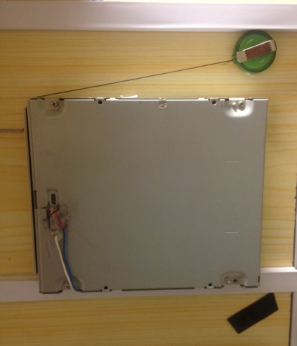
Fig. 5 Door and closing mechanism

3 bump sensors are also placed on a vertical rail at each floor in a way that the cabin presses accurately the sensor corresponding to the floor at which it is.

A laser pointer is fixed at the cabin entrance and hits continuously a photovoltaic resistor (Fig. 6). If an obstacle prevent the light from reaching the resistor, the door motor remains on until the obstacle is cleared.
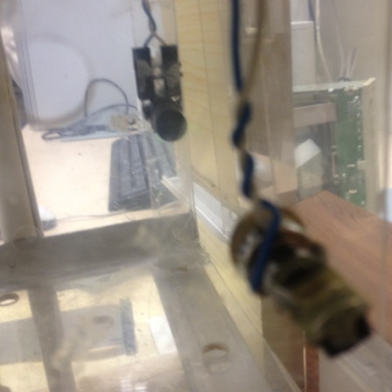
Fig. 6 Door sensor system

In addition, a temperature sensor is installed inside the cabin. If the temperature goes above the fixed threshold, the cabin goes into an emergency mode: a dc fan is then turned on as well as some red LEDs.
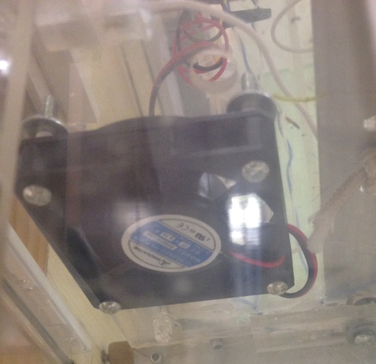
Fig. 7 dc fan

The cabin can be also called at any of the three floors using a single frequency tone. In auxiliary cable connects the analog input of Speedy to the output of the iPhone where a tone simulator is installed.

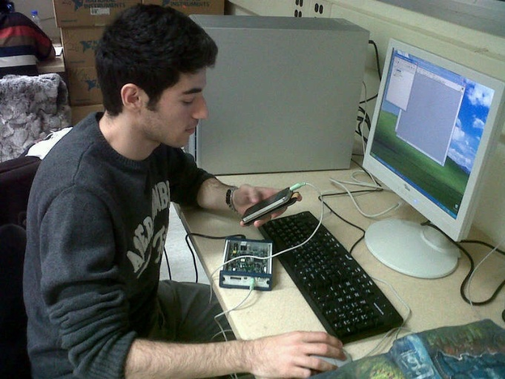
Fig. 8 iPhone connected to Speedy

All the wires coming out from the different electronic components installed inside the elevator are connected to an interface board (Fig.9) attached to the Speedy board with a flat cable.

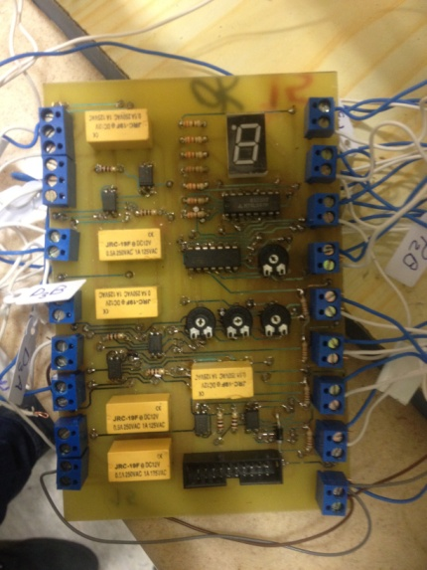
Fig. 9 Interface Board

- Gantt Chart

Fig. 10 Gantt Chart

- Alternative Designs Discussion

- First Design

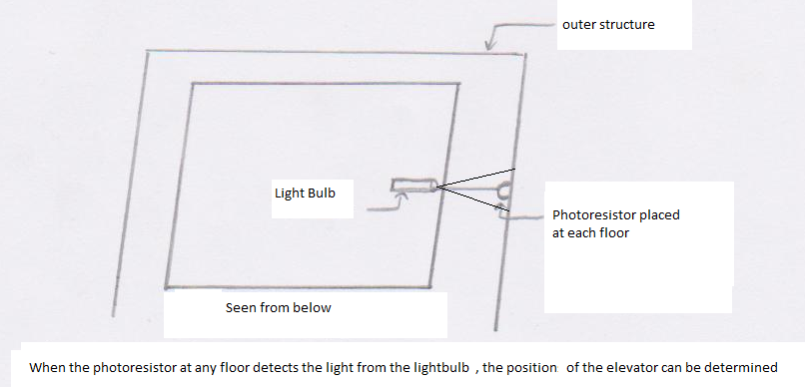
Fig. 11 Positioning System

Three photo resistors are installed on each floor on the inside of the shaft, and one large radius light bulb is fixed below the elevator cabin (Fig. 11). When the cabin reaches a level, the light from the light bulb hits the photo resistor and the sensor circuit is closed, indicating the presence of the cabin on that floor. When no light hits the sensor the circuit is opened.

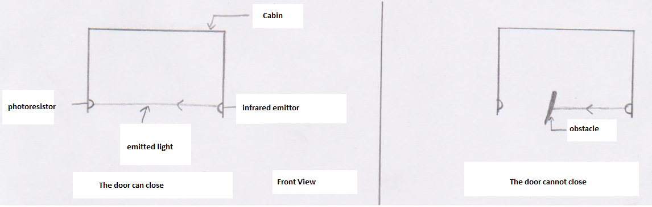

Fig. 12 Door Sensor

A single photo resistor is placed in the inside of the cabin with an infrared source constantly hitting it (Fig. 12). When something obstructs the infrared beam, no light hits the photo resistor and the circuit is open, preventing the door from closing.
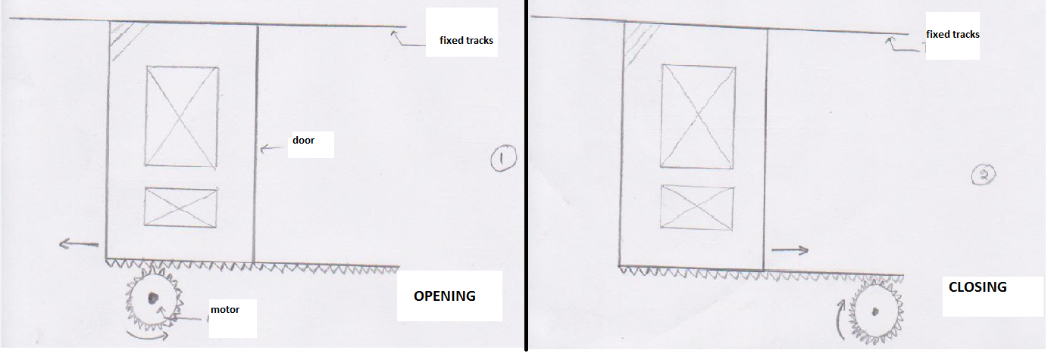
Fig. 13 Doors System
A motor with gears is attached to the door on each level (Fig. 13), a command opens half of it with one rotational motion (clockwise) and closes with a second command that turns it in the opposite rotational motion (counter clockwise).

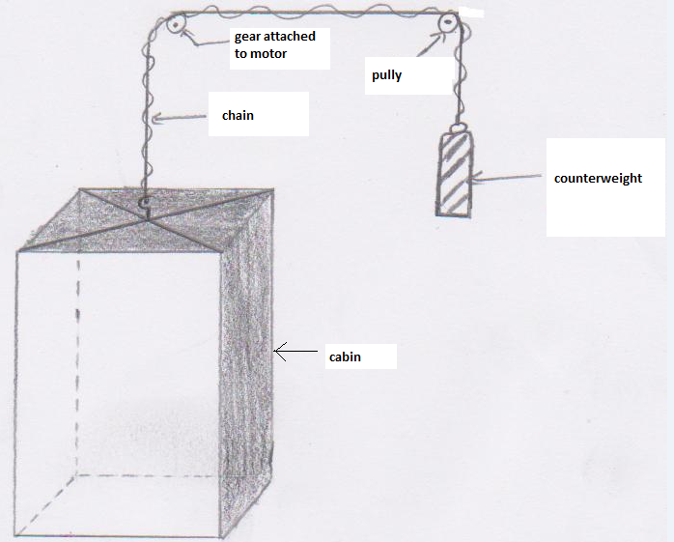

Fig. 14 Lifting System

A motor on the top of the shaft pulls and drops a counterweight connected to the cabin. When the motor isn’t running, the counterweight prevents the cabin from sliding.
- Second Design
The infrared emitter used for the door sensor, is replaced by a laser pointer.
A metal plate is placed underneath the cabin with a piece sticking out, and on each floor an open circuit that close when the metal piece of the elevator comes in contact with it, indicating the presence of the elevator on that floor.
- Third Design
Bump sensors are places at each floor instead of the photo-resistor.

- Anticipated Costs
Article |  | Quantity |  | Unit price |  | Total Price
Speedy 33 |  | 1 |  | $600 |  | $600
Big pulling motor |  | 1 |  | $10 |  | $10
Motors for the doors |  | 3 |  | $5 |  | $15
Temperature sensor |  | 1 |  | $2 |  | $2
Photo resistors  Lasers |  | 4  4 |  | $2  $5 |  | $8  $20
LED Lights |  | 6 |  | $1 |  | $6
Cabin + shaft (Aluminum)  Wheels  Pulley + Tracks + Gears  Wiring |  | 1  5 |  | $22  $2 |  | $22  $10  $16  $5
Estimated Total Amount |  |  |  |  |  | $714

- Final Costs Summary
Article |  | Quantity |  | Unit price |  | Total Price
Speedy 33 |  | 1 |  | $600 |  | $600
Big pulling motor |  | 1 |  | $10 |  | $10
CD-ROMs |  | 3 |  | $10 |  | $30
Temperature sensor |  | 1 |  | $2 |  | $2
Photo resistors  Lasers |  | 1  2 |  | $2  $5 |  | $2  $10
LED Lights |  | 6 |  | $1 |  | $6
Wood  Plexi-Glass  Pulley + Tracks + Gears  Wiring  Cutting Fees |  | 2m²  1m² |  | $8  $15 |  | $16  $15  $16  $10  $10
Estimated Total Amount |  |  |  |  |  | $727

Comparing the effective price with the price we wrote in the proposal, it turns out we paid slightly more than what we have anticipated on paying. We predicted that we had to pay 714$ but we paid instead 727$ which is not a big difference.

Name | Qualifications | Allocated part of the project
Julien Rahal | Great organizational and cooperative skills. Clear understanding of the procedure and project material. Also has a skill in illustrating and drawing sketches. | Assures the complete interaction between the group members. Drew the designs clearly after they have been presented as essential ideas.  Major role in realizing the hardware and the final report.
Yves Takchi | Deep understanding of the material and know-how of the project realization procedure, and mastery of the English writing language. | Presenting the basic ideas about the project and knowledge about where to find each material needed. Did the initial. Participated in editing the final draft of the proposal.  Major role in building the software and hardware.
Christian Massabni | Very good leadership and organizational skills. Time management skills. Basic understanding of all the information presented during group discussions. | Organization of the group work and control over all the work done. Time management for the group. Participated in editing the final draft of the proposal.  Major role in building the software and reports.
Rita Yachoui | Good mastery of the English Language. Responsible for typing the proposal report. Offering creative ideas and additional aspects and components for the project. | Doing research on the subject. Participation in the group discussions as well as offering ideas.

The project was very useful and had several important benefits.
It taught us how to work in a group and be able to divide the work equally among the group members. It taught us how to respect the notion of time and deliver all the required before the deadline. We learned through it how to discover the answers to our problem on our own and face the challenges as a team. It made us go through all the problem solving steps and prepared us somewhat for the future.

It was a very important project for us since it was our first and it was our chance to prove ourselves and show what we’re capable of. It was a very interesting assignment and we enjoyed working on it and were even more amused with the results. We know now what to expect in the projects to come and we are now ready to take on the next challenge.

Proposal report:

http://www.ece.rutgers.edu/~marsic/Teaching/SE/proposal.htm

Temperature Sensor

http://www.vernier.com/probes/temperature.html

Photo resistors
http://www.ladyada.net/learn/sensors/cds.html

Creating Gantt Chart
http://www.youtube.com/watch?v=HQwE0Xv1lAAhttp://www.youtube.com/watch?v=HQwE0Xv1lAA

http://moodle.aub.edu.lb/course/view.php?id=4260

